Project Design Phase
Problem – Solution Fit Template

Date | 25 June 2026
Team ID
Project Name | An employee requests installation of licensed software through the Service Catalog
Maximum Marks | 2 Marks

Problem – Solution Fit Template:
The Software Installation Request System automates the process of requesting licensed software using ServiceNow. Employees submit requests through the Service Catalog, managers approve them, and the Software Support Team receives automated installation tasks. The system provides request tracking, notifications, role-based access, and faster software delivery with improved transparency and efficiency.
Purpose:
- Automate the complete software installation request process from submission to fulfillment.
- Reduce manual effort by implementing workflow-based approvals and task automation.
- Improve user experience through a centralized Service Catalog and real-time request tracking.
- Ensure secure and role-based processing using ServiceNow access controls and approval workflows.
- Increase operational efficiency, transparency, and compliance in managing licensed software requests.
- Provide a scalable solution that can be extended to other IT service requests in the future.
Template:
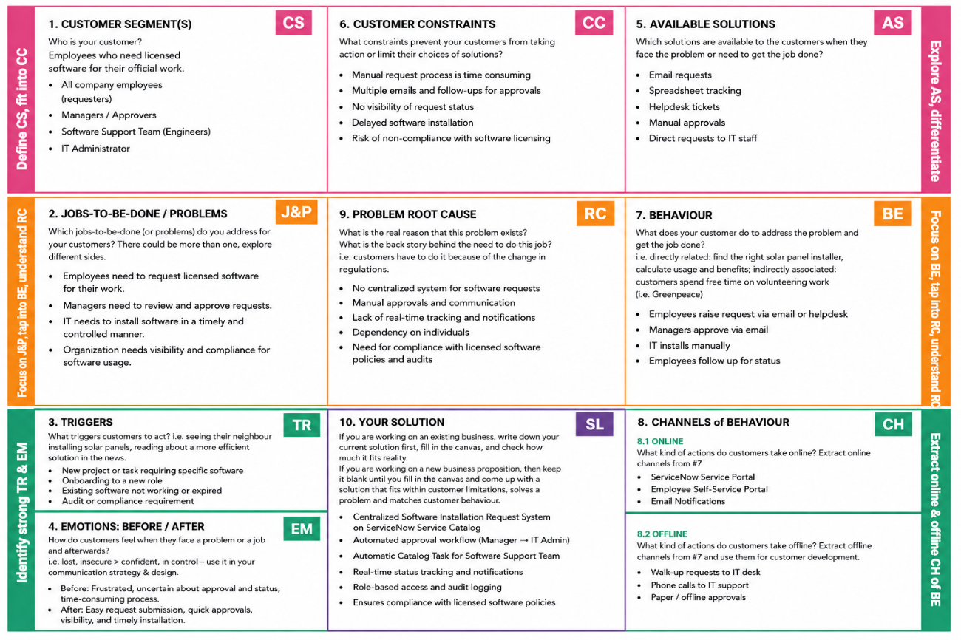
References:
- https://www.ideahackers.network/problem-solution-fit-canvas/
- https://medium.com/@epicantus/problem-solution-fit-canvas-aa3dd59cb4fe

